### Build An Event Management System Using Salesforce

### The Event Management System using Salesforce is a project that involves developing a customized solution for managing events using the Salesforce platform. It includes features such as event registration, attendee management, scheduling, and reporting, all integrated within the Salesforce CRM. This system can be used by event organizers to streamline their event management processes and improve their efficiency in organizing events.

* Build An Event Management System Using Salesforce
  + Salesforce
    - Creating A Salesforce Developer Org
      * Developer Edition Link
  + Object
    - Creation Of Objects For Event Management

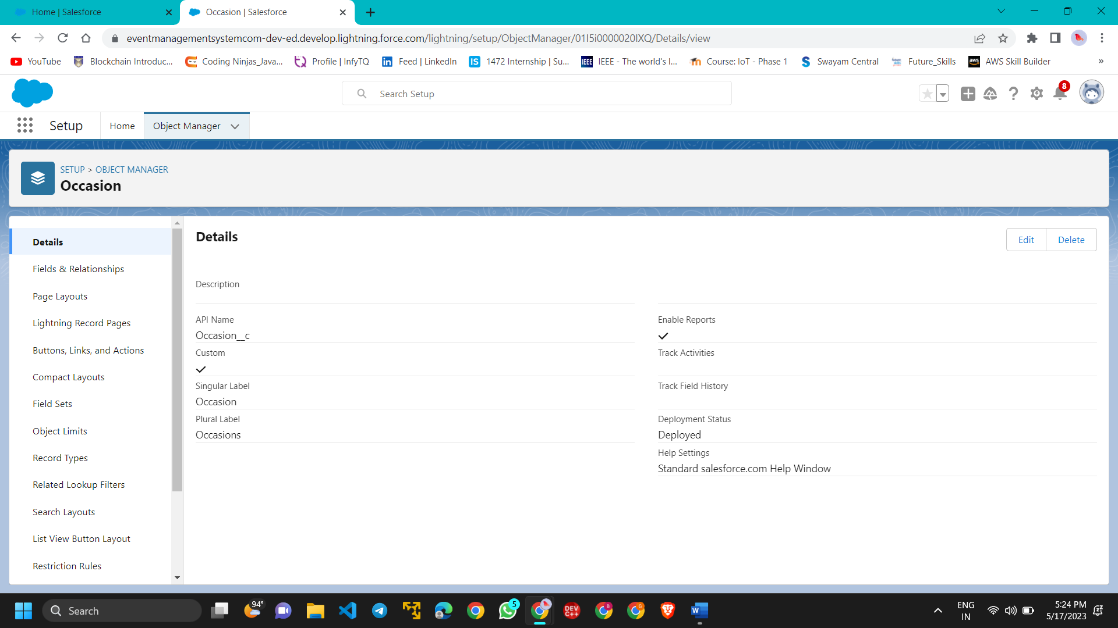

* + - Creation Of Attendees Object

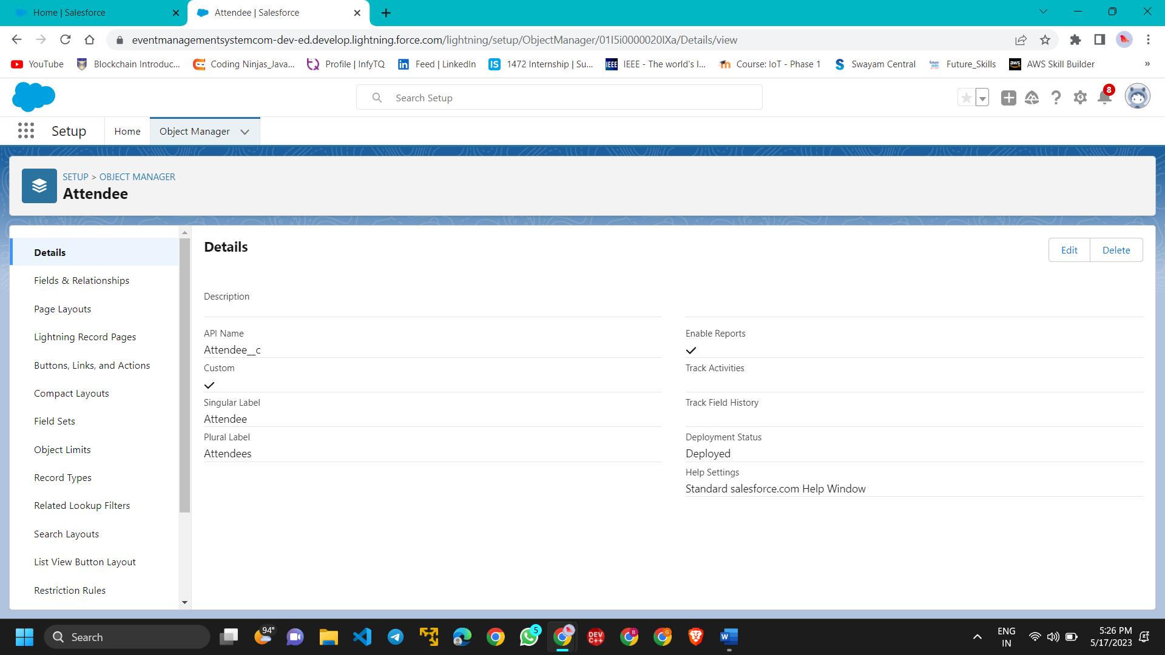

* + - Creation Of Speaker Object

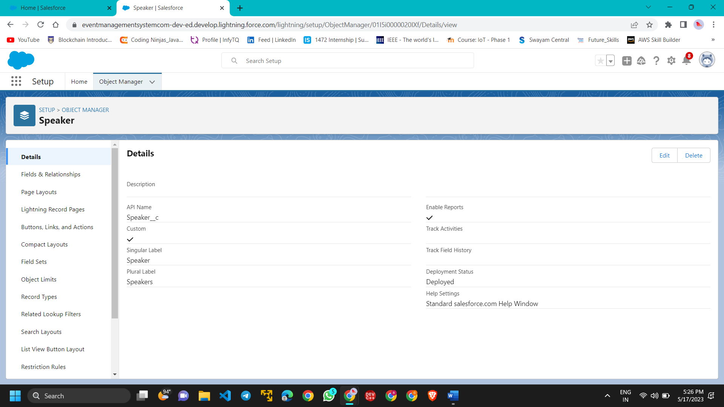

* + - Creation Of Vendors Object

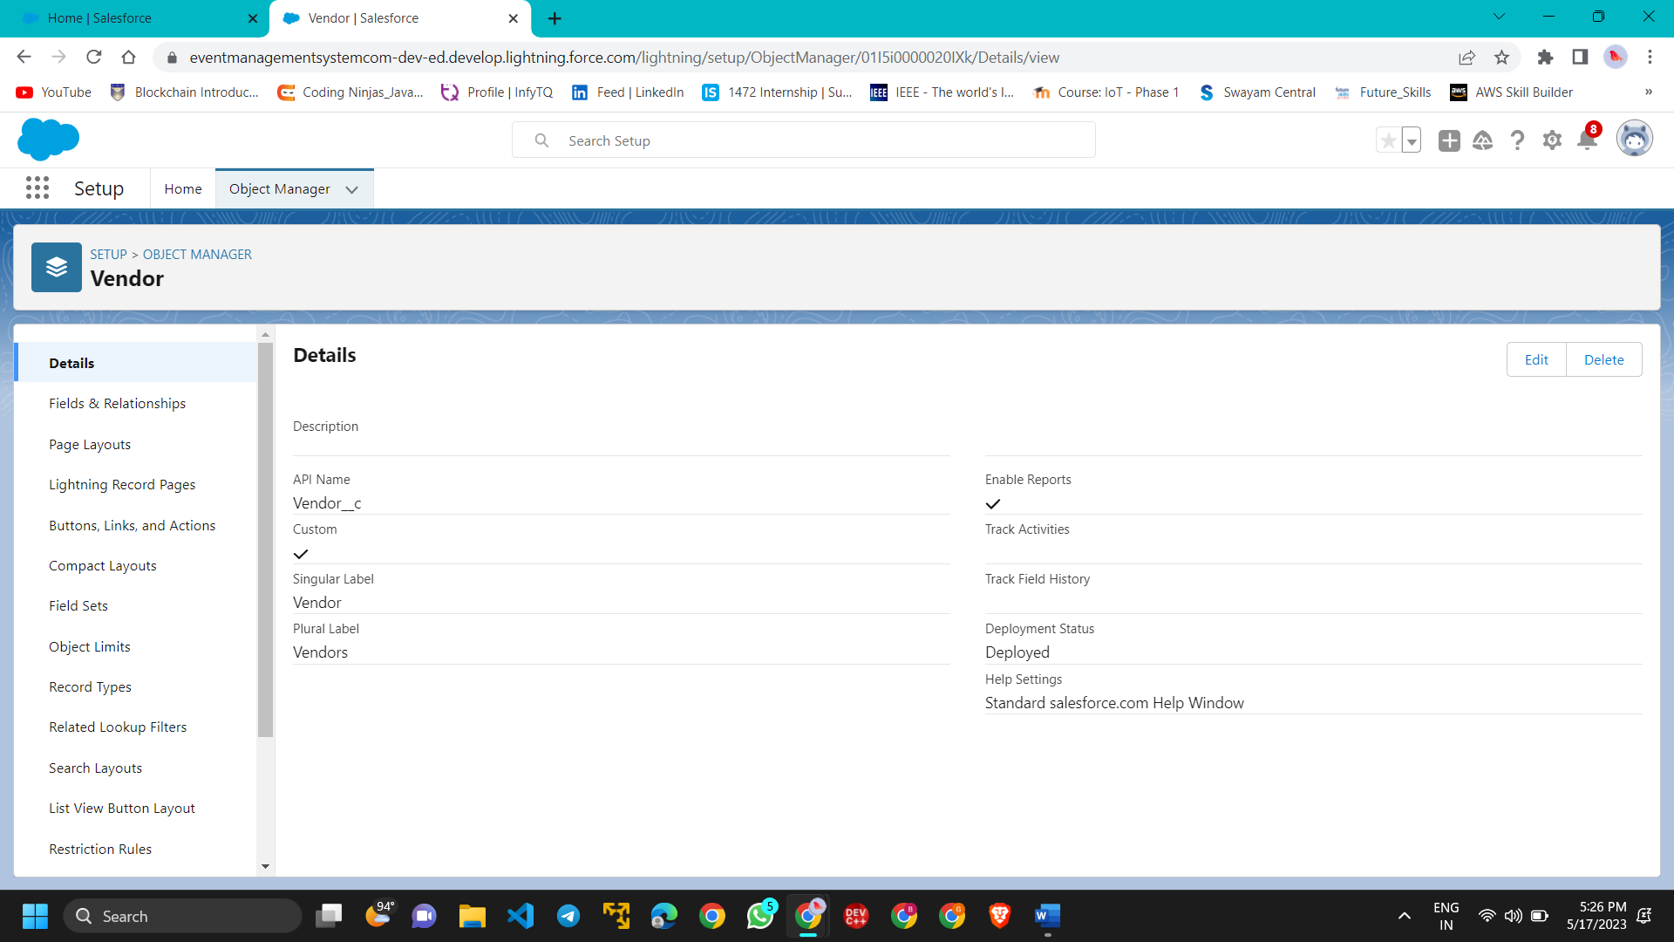

* + - Creation Of Event Service Object

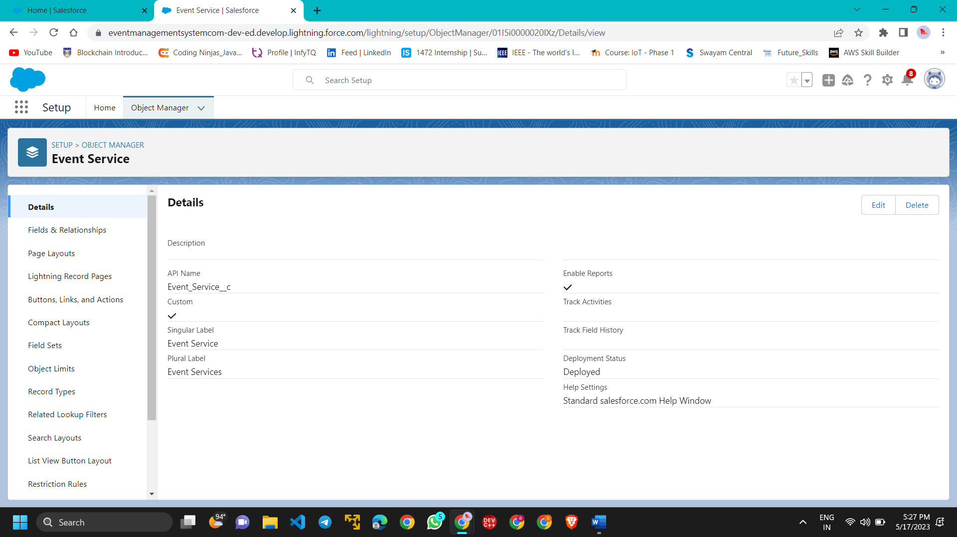

* + Tab
    - Creation Of Occasion Tab
    - Creation Of Attendee Tab
    - Creation Of Speakers Tab
    - Creation Of Vendor Tab
    - Creation Of Event Service Tab

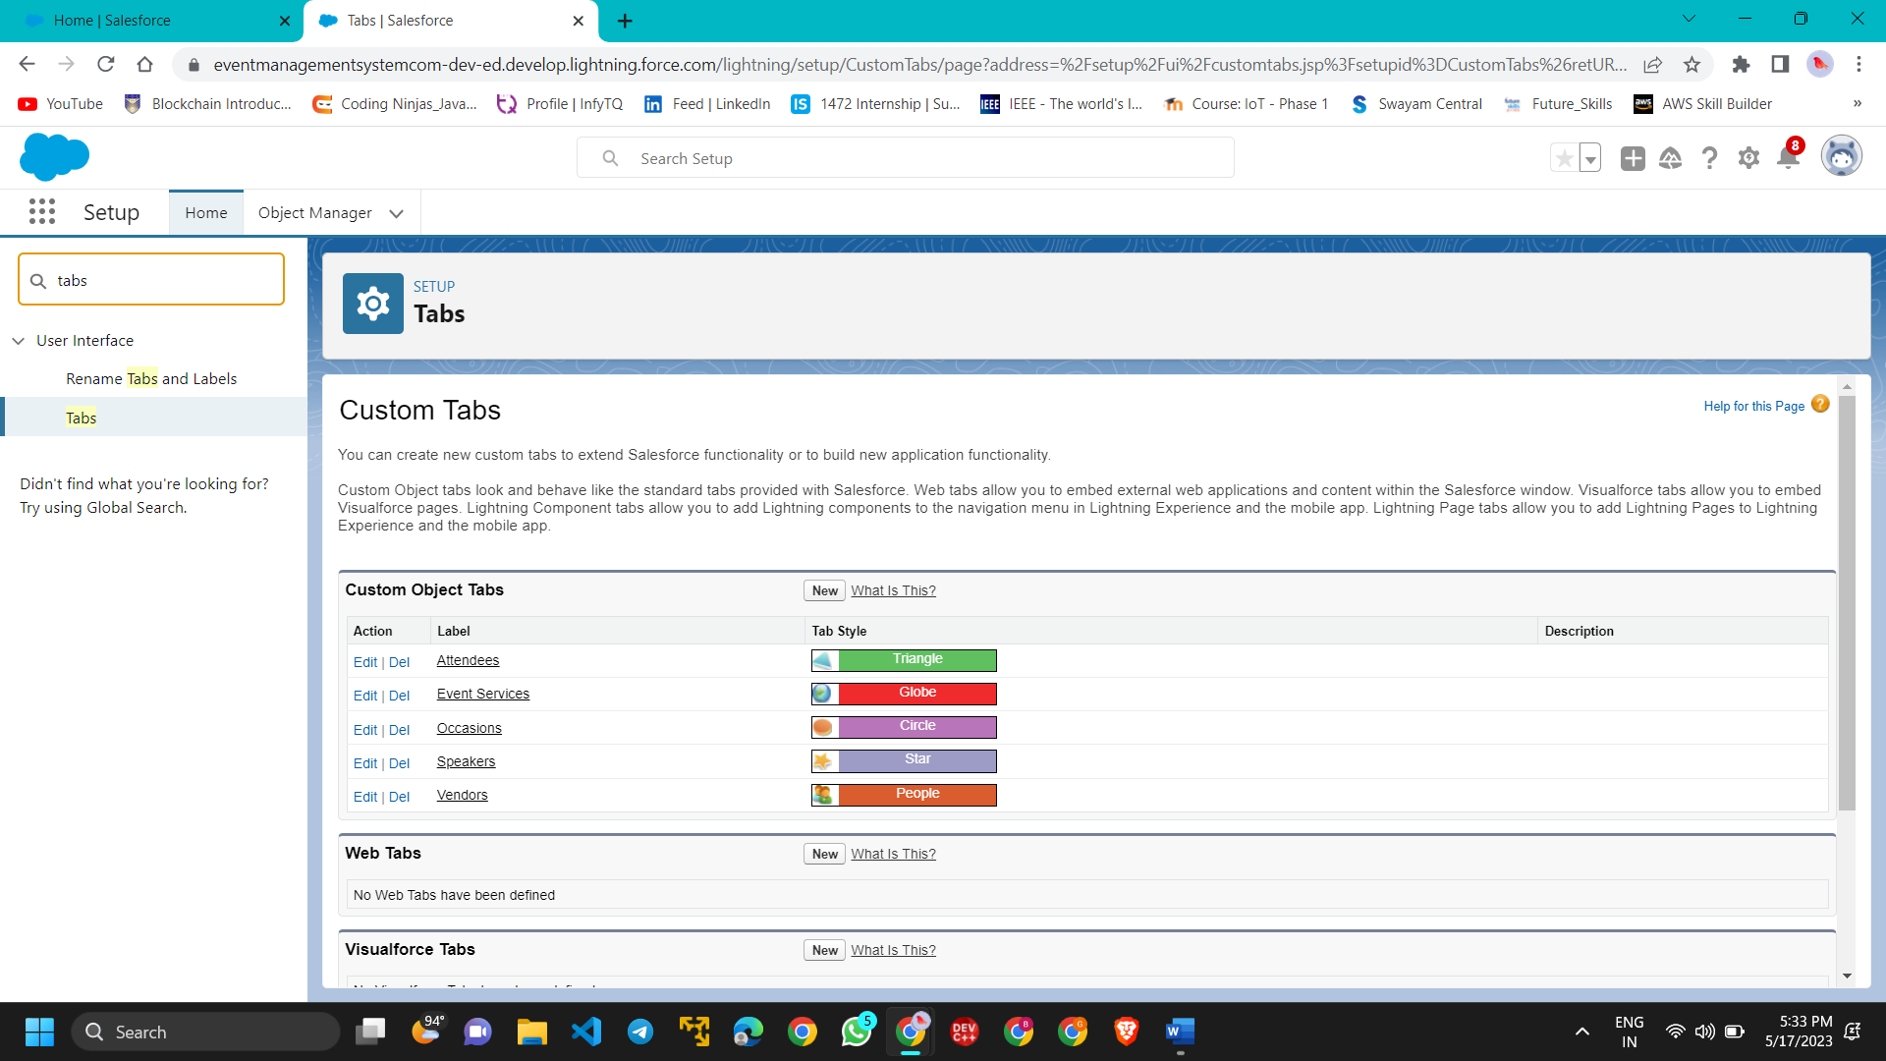

* + Lightning App
    - Create The Event Management App

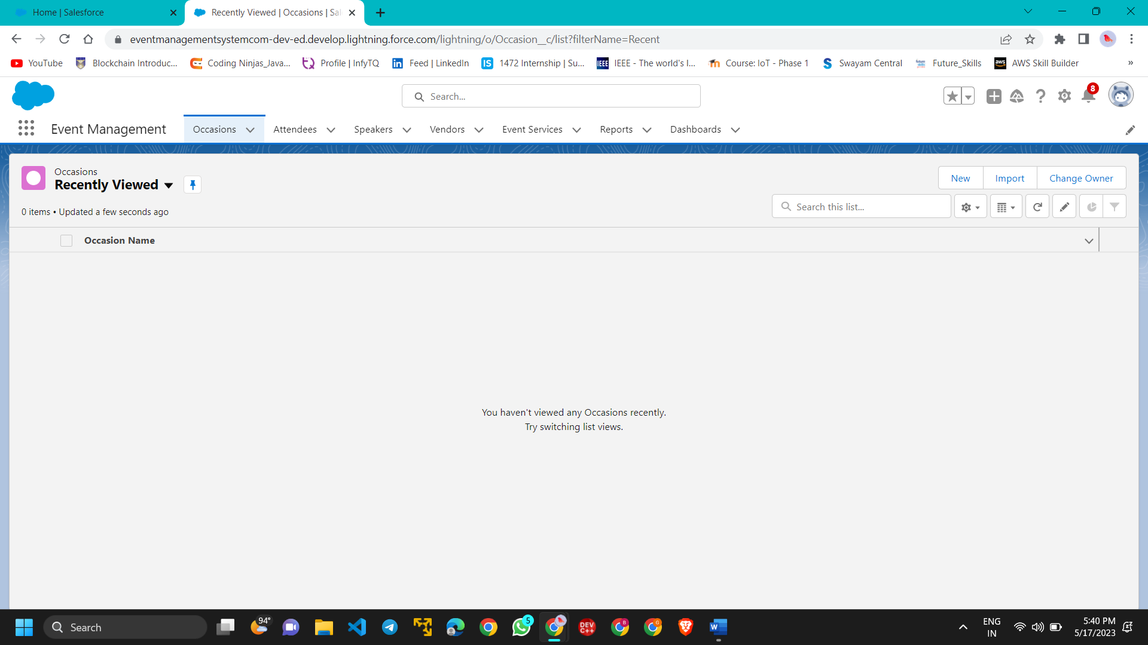

* + Fields And Relationships
    - Creation Of Fields For The Occasion Objects

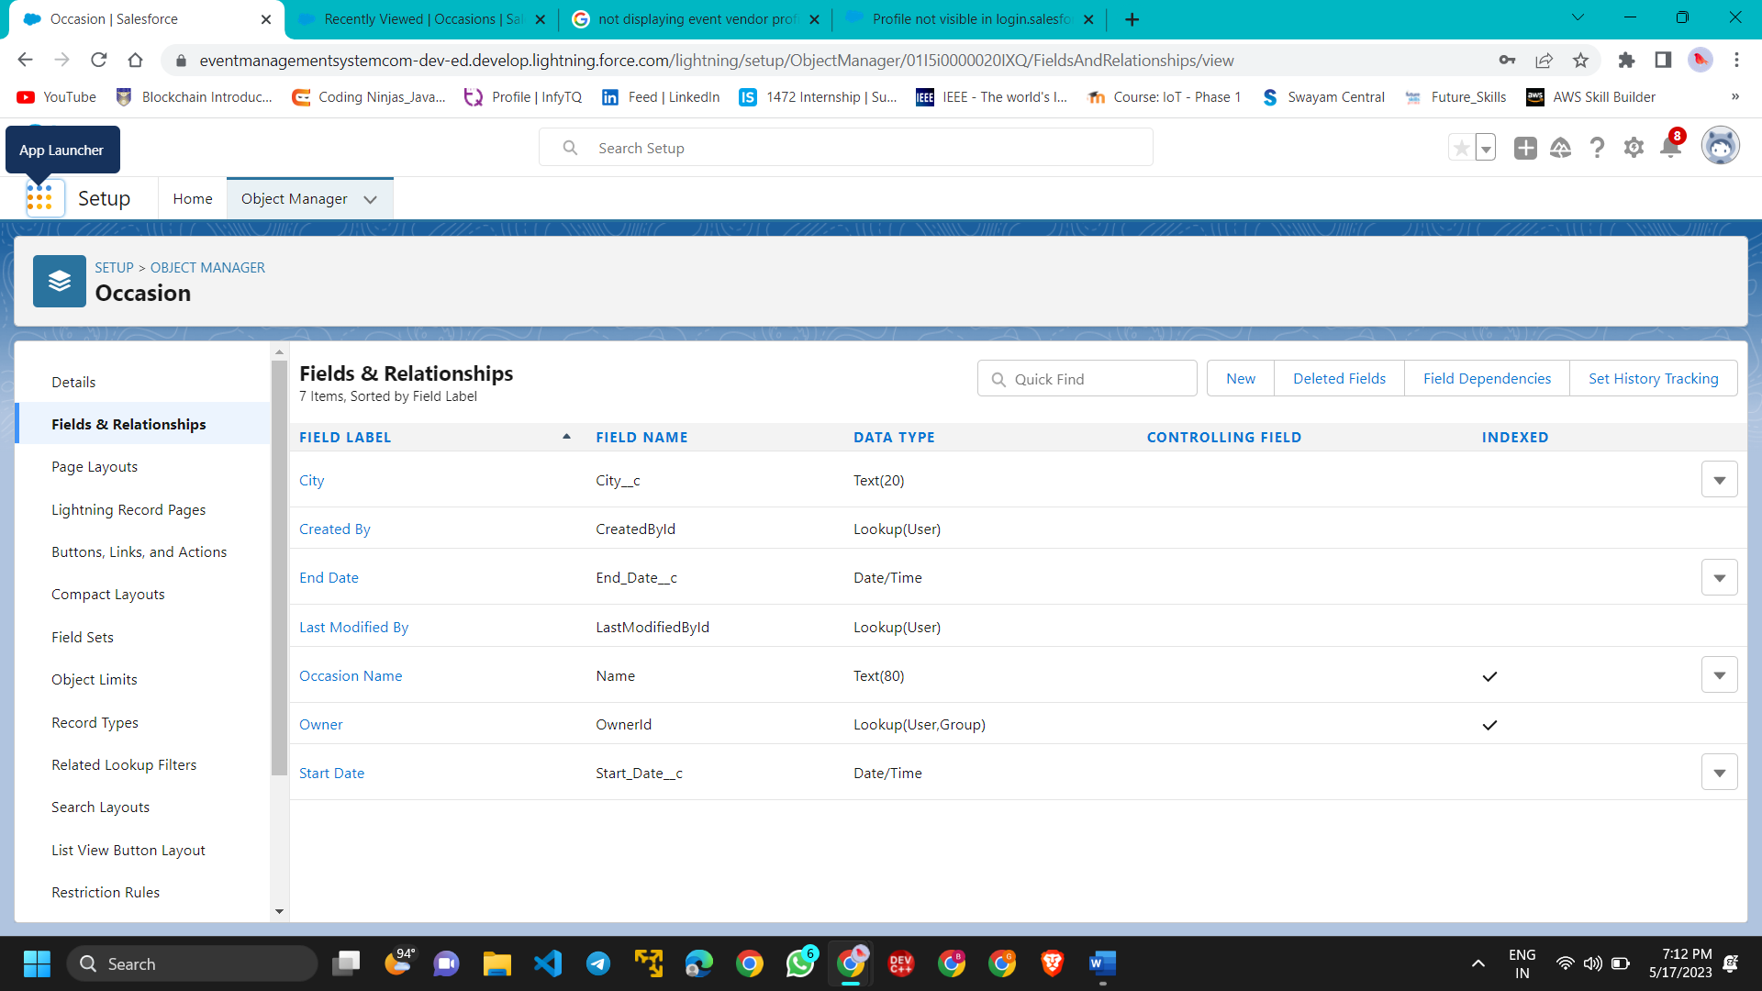

* + - Creation Of Fields For The Attendees Objects

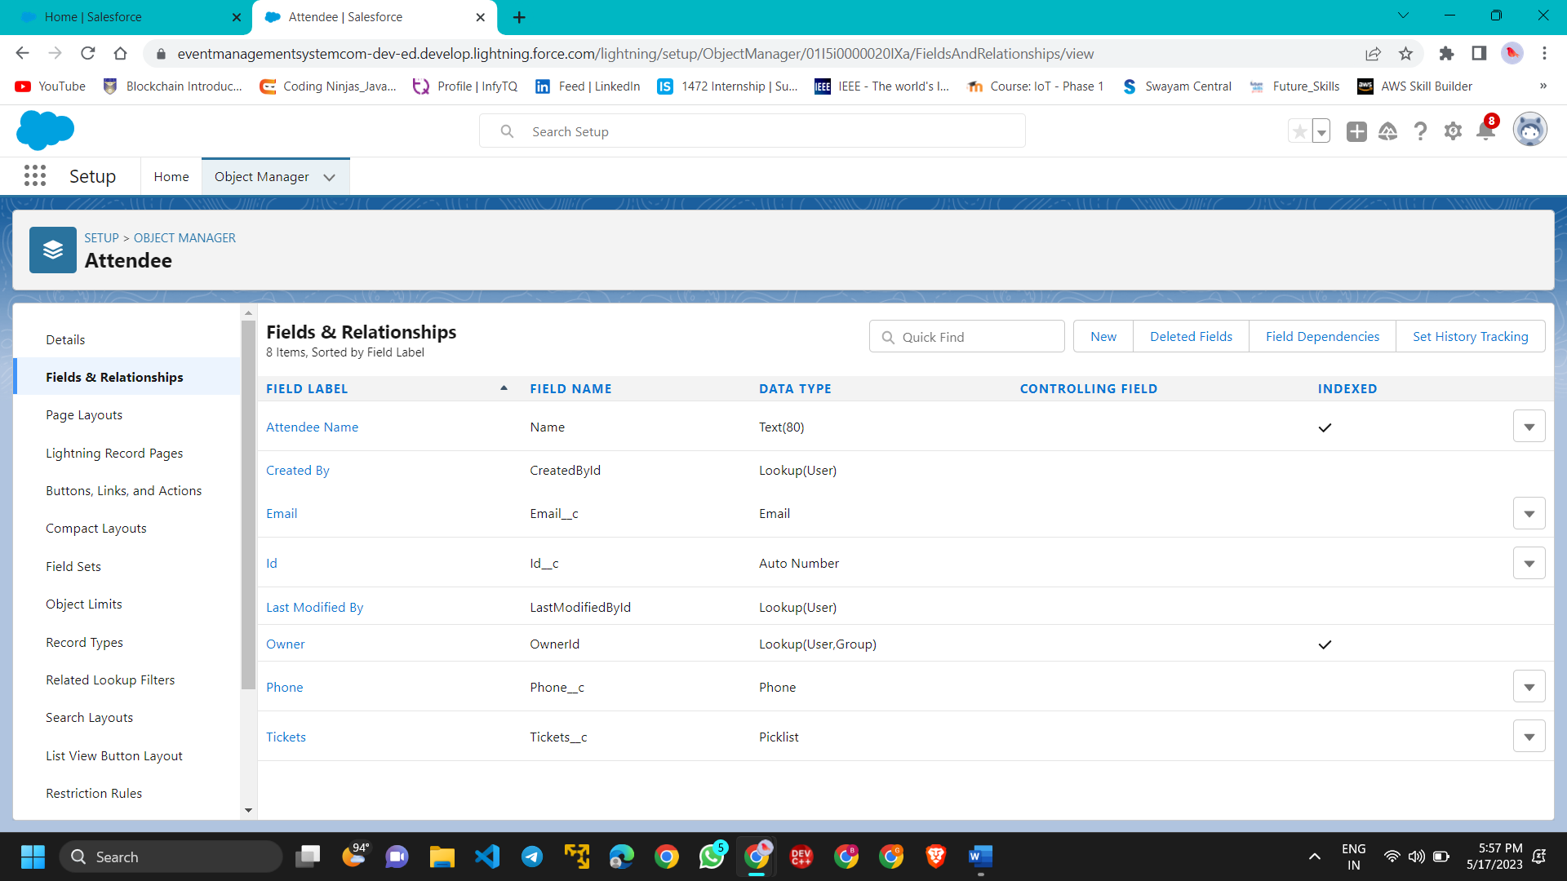

* + - Creation Of Master-Detail Relationship

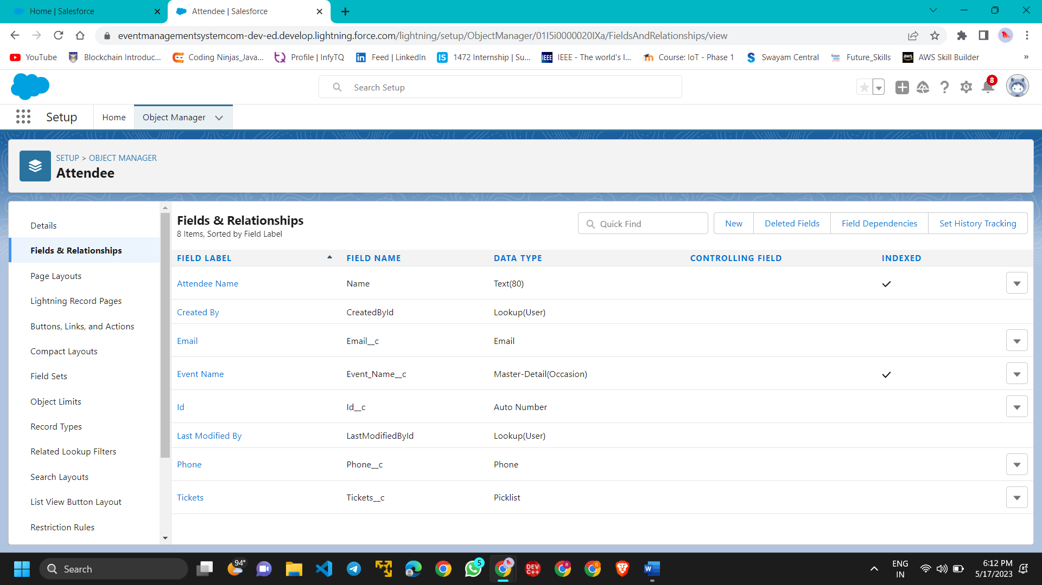

* + - Creation Of Fields For The Speakers Objects

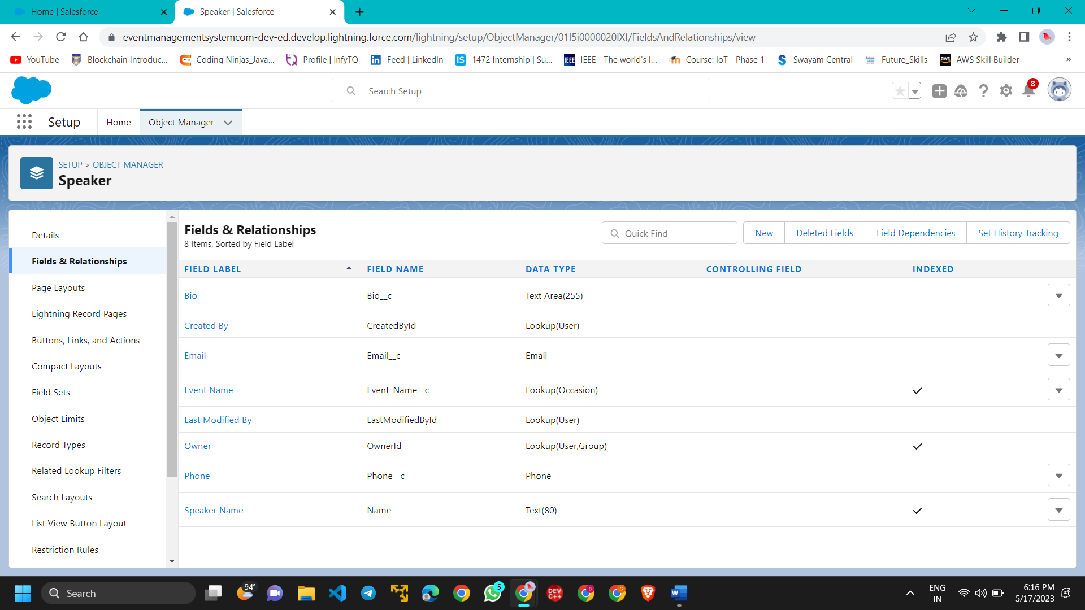

* + - Creation Of Fields For The Vendors Objects

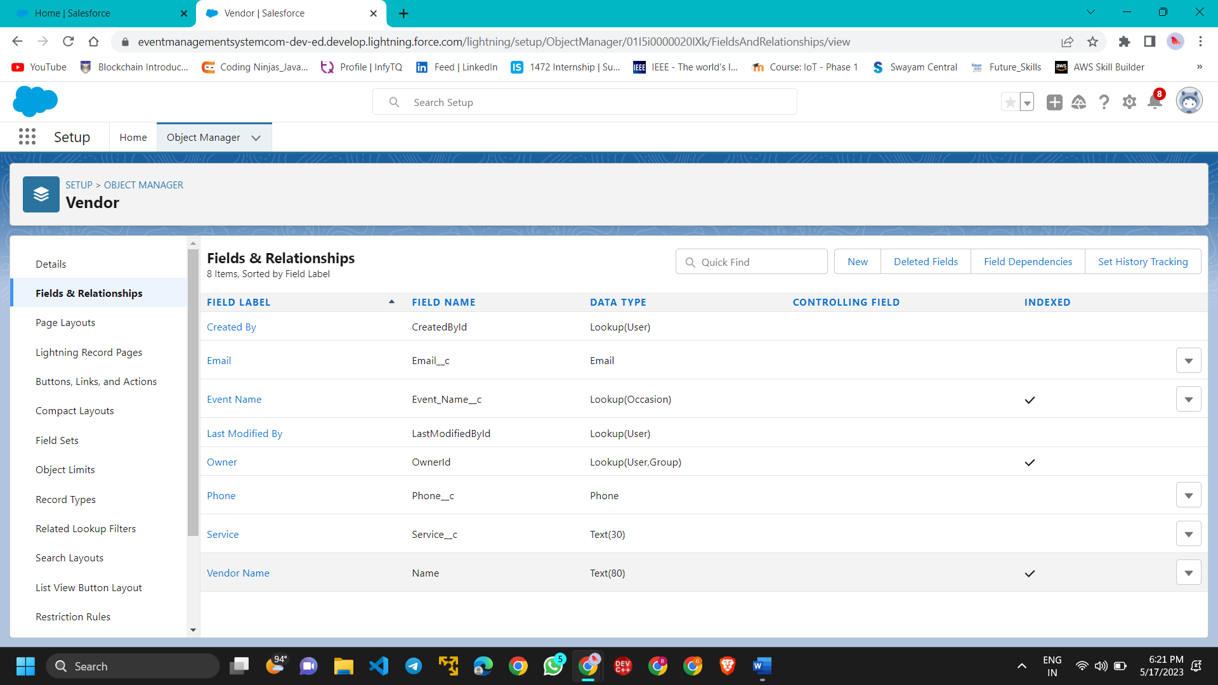

* + - Creation Relationship On Event Service Objects

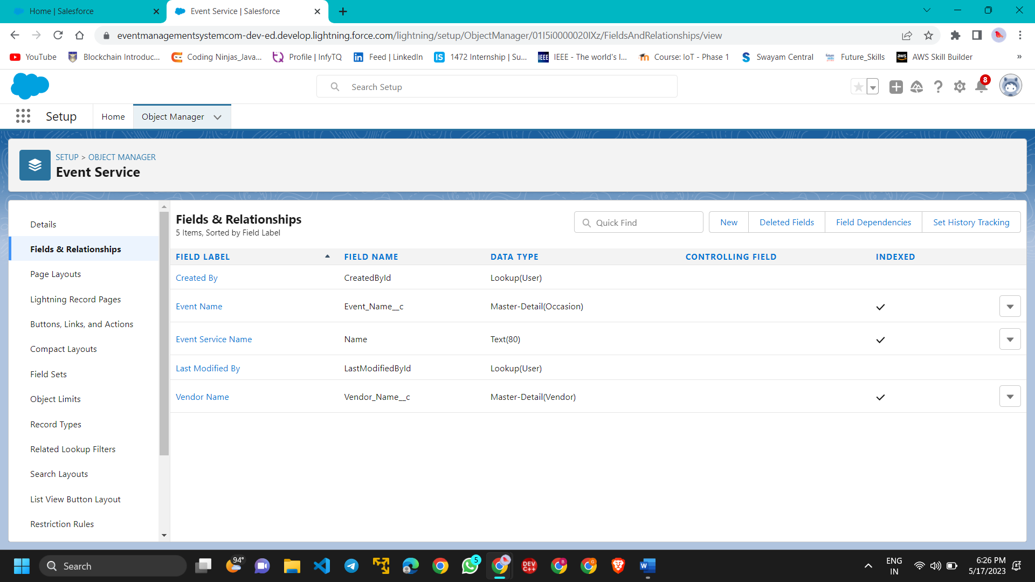

* + Profile
    - Creation On Profile

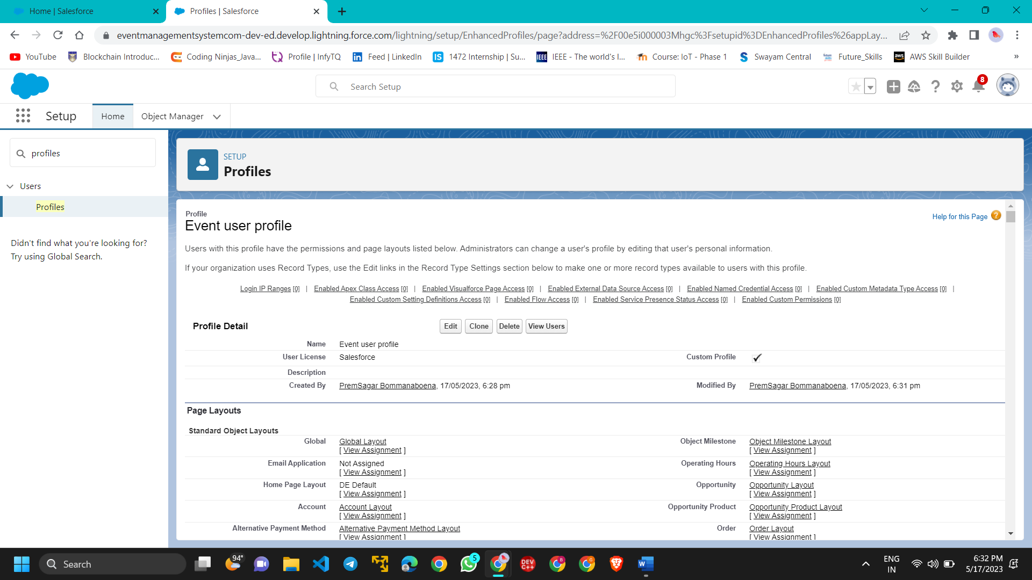

* + - Create A Profile With The Profile Name As “Event Vendors Profile”

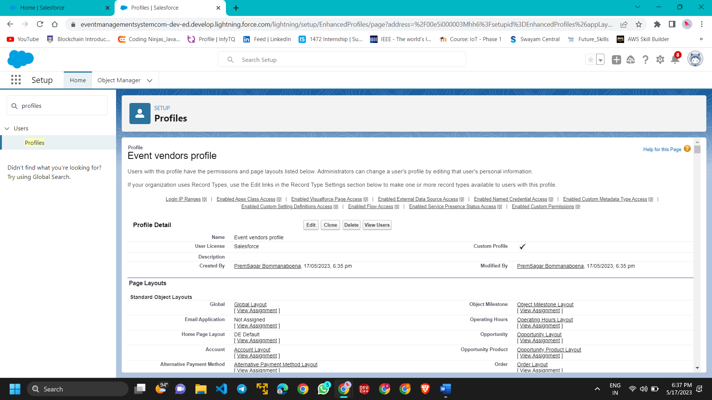

* + User
    - Creating A User

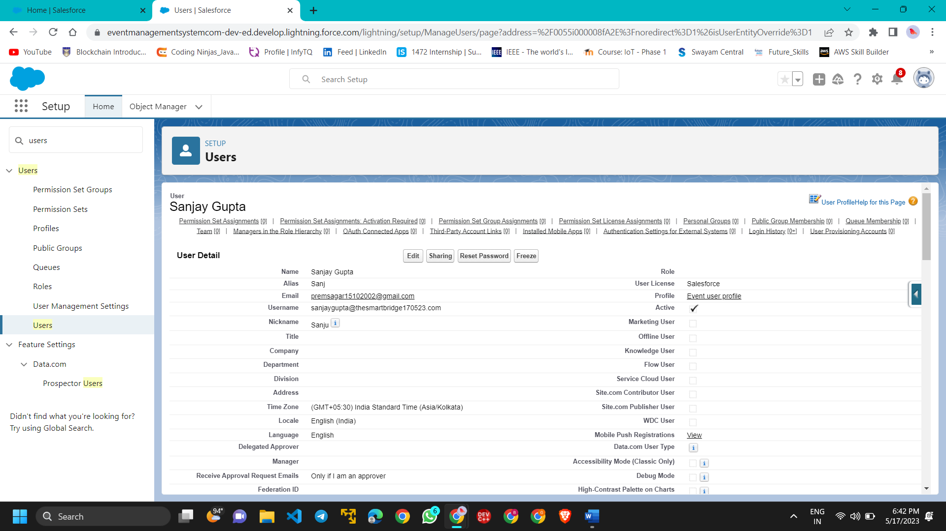

* + - Creating A Another User

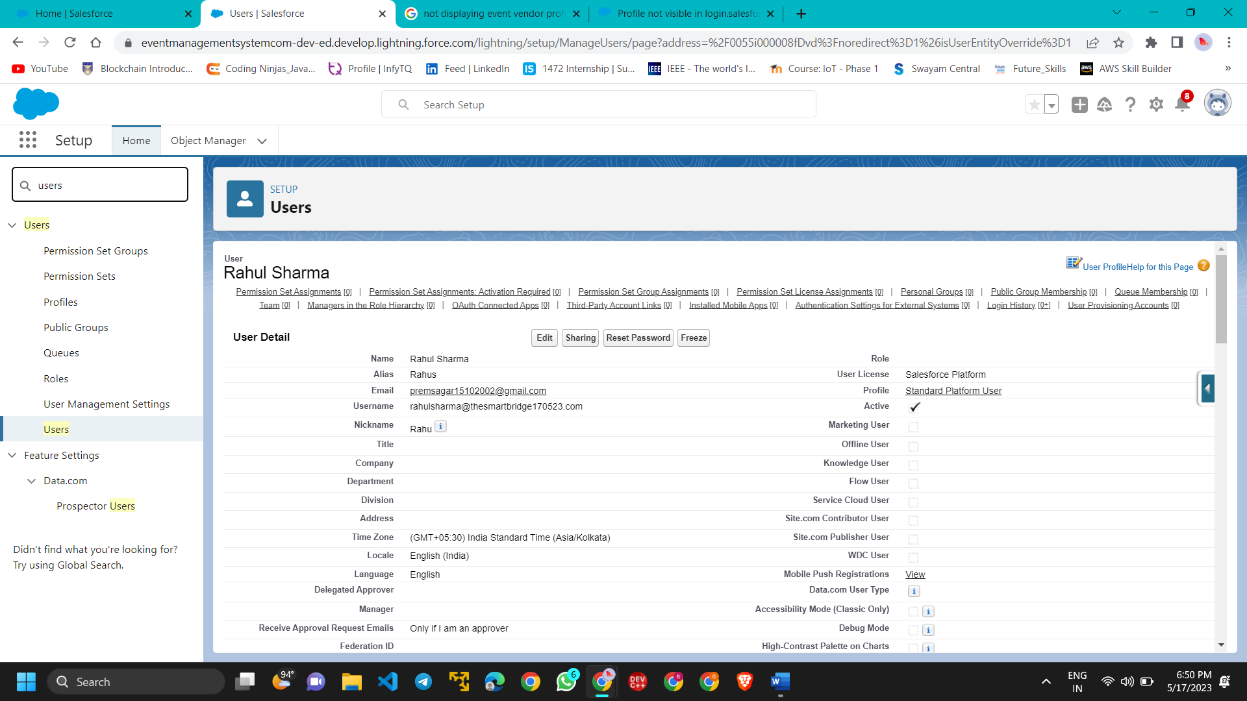

* + Permission Sets
    - Creating A Permission Set

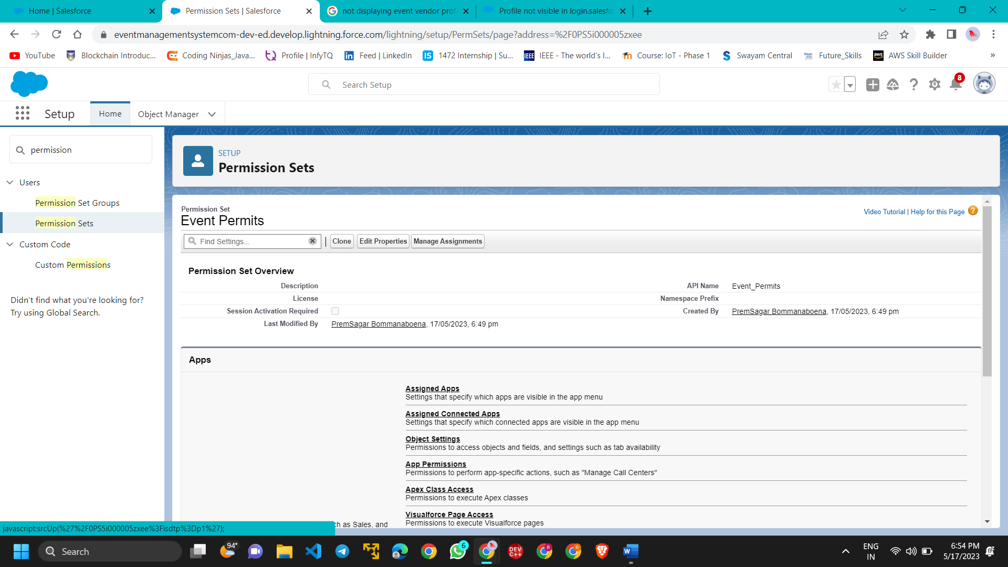

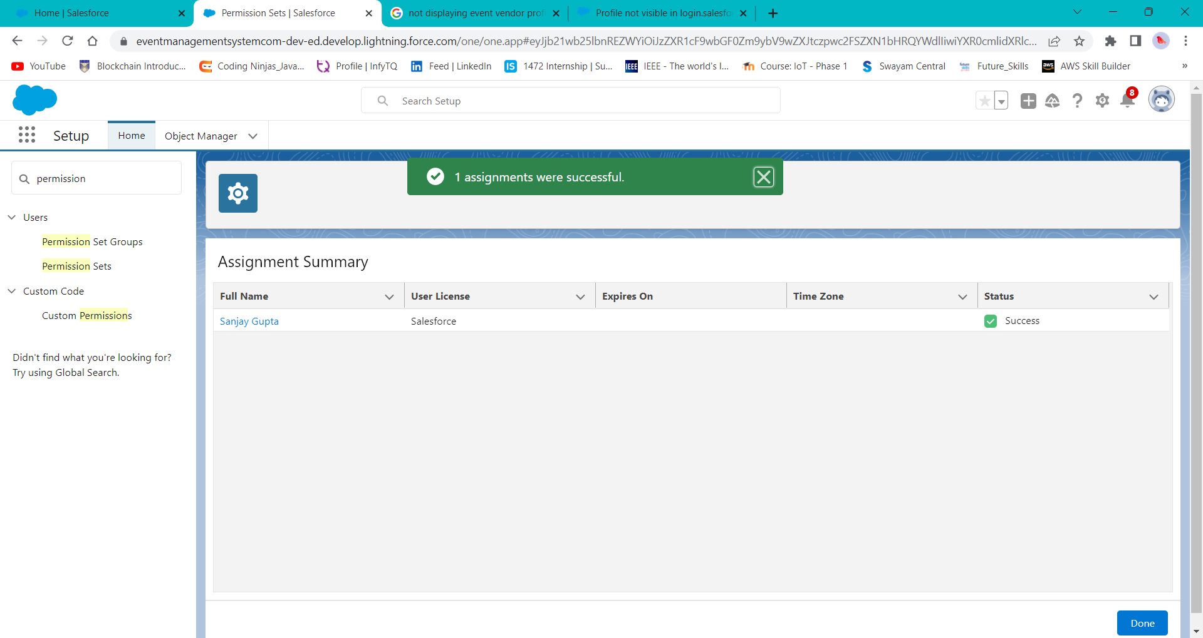

* + - Creating A Another Permission Set

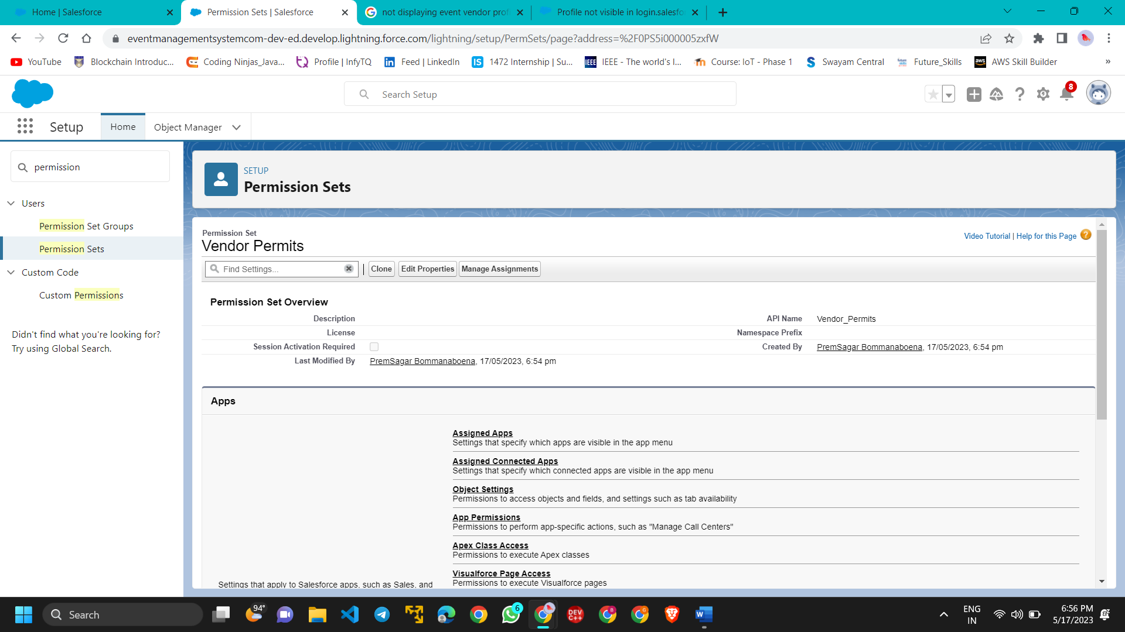

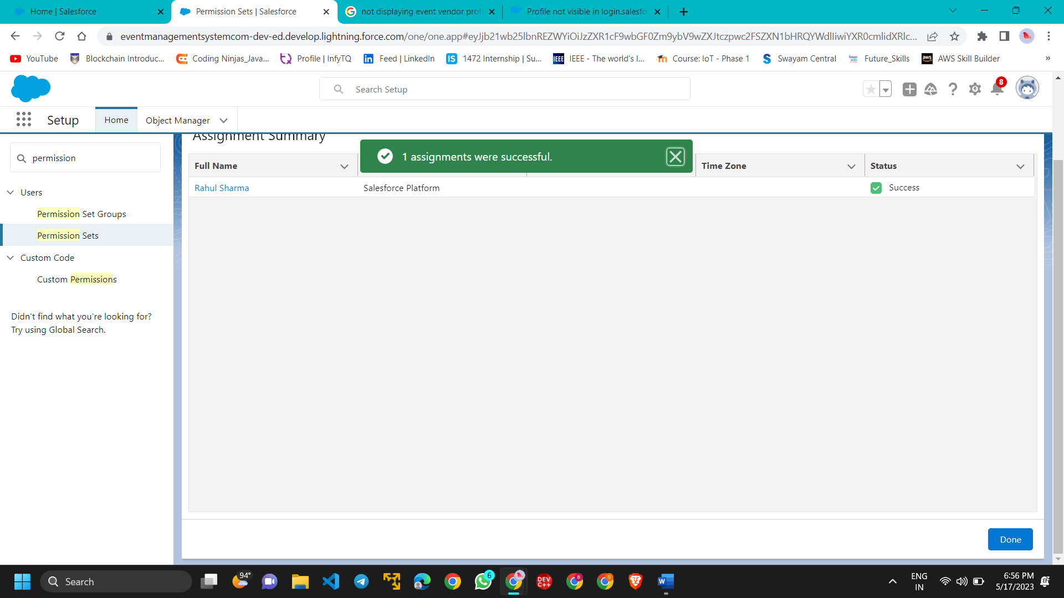

* + User Adoption
    - Create A Record (Occasion)

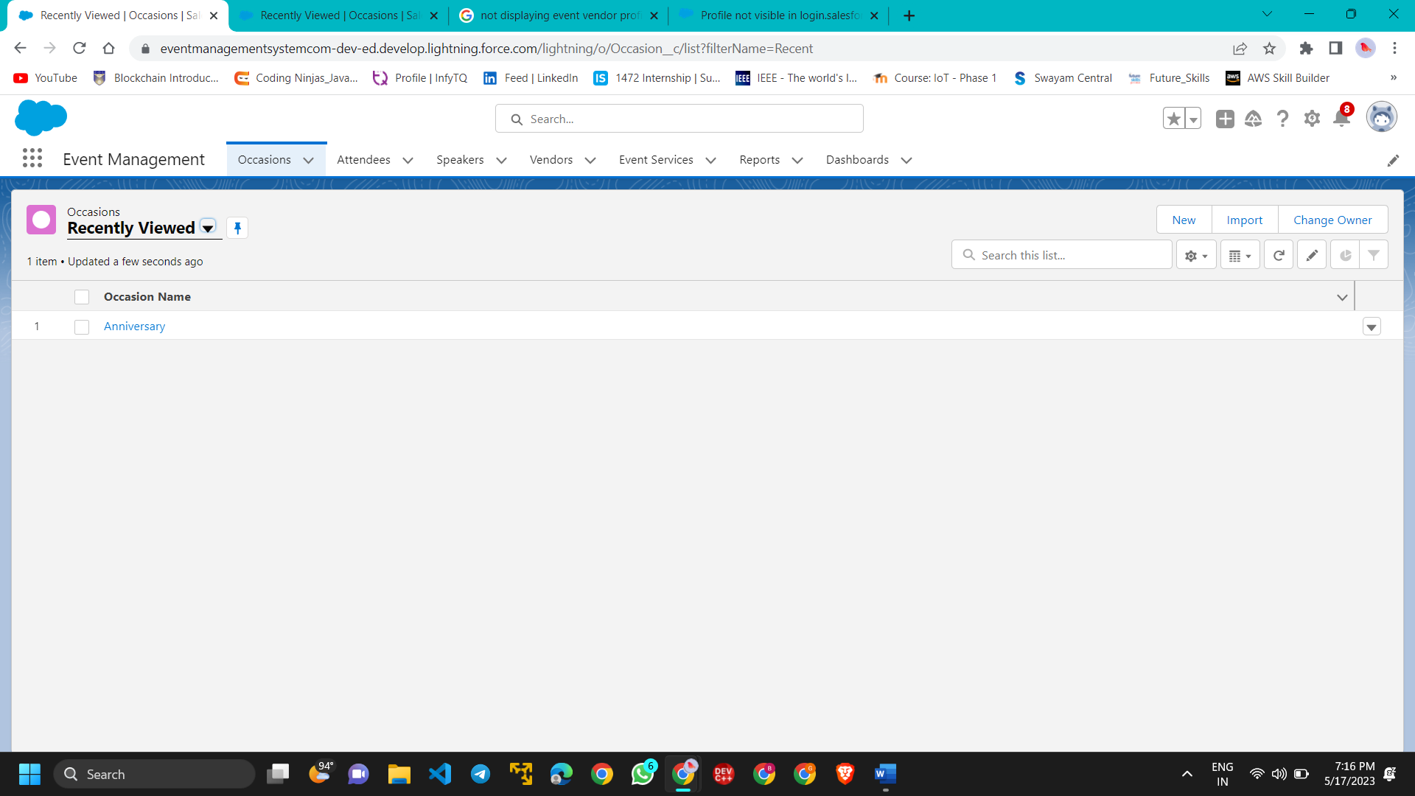

* + - View A Record(Occasion)

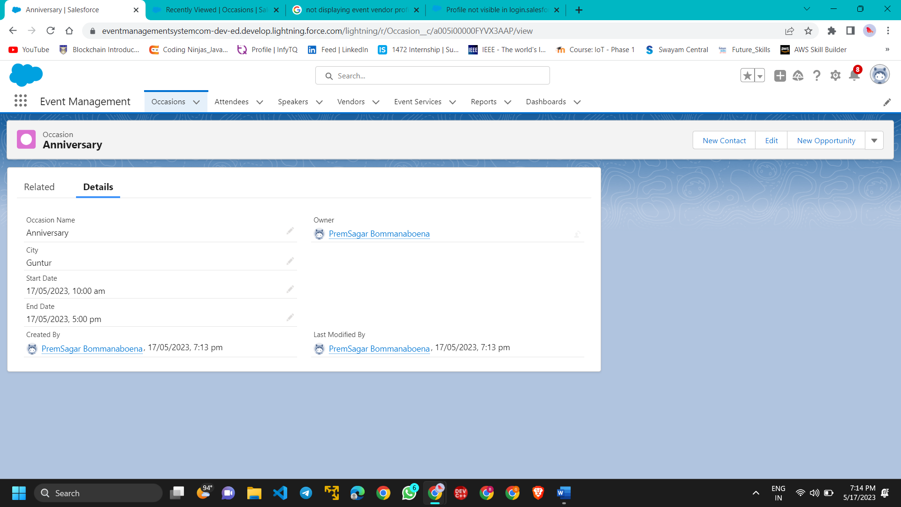

* + - Delete A Record(Occasion)

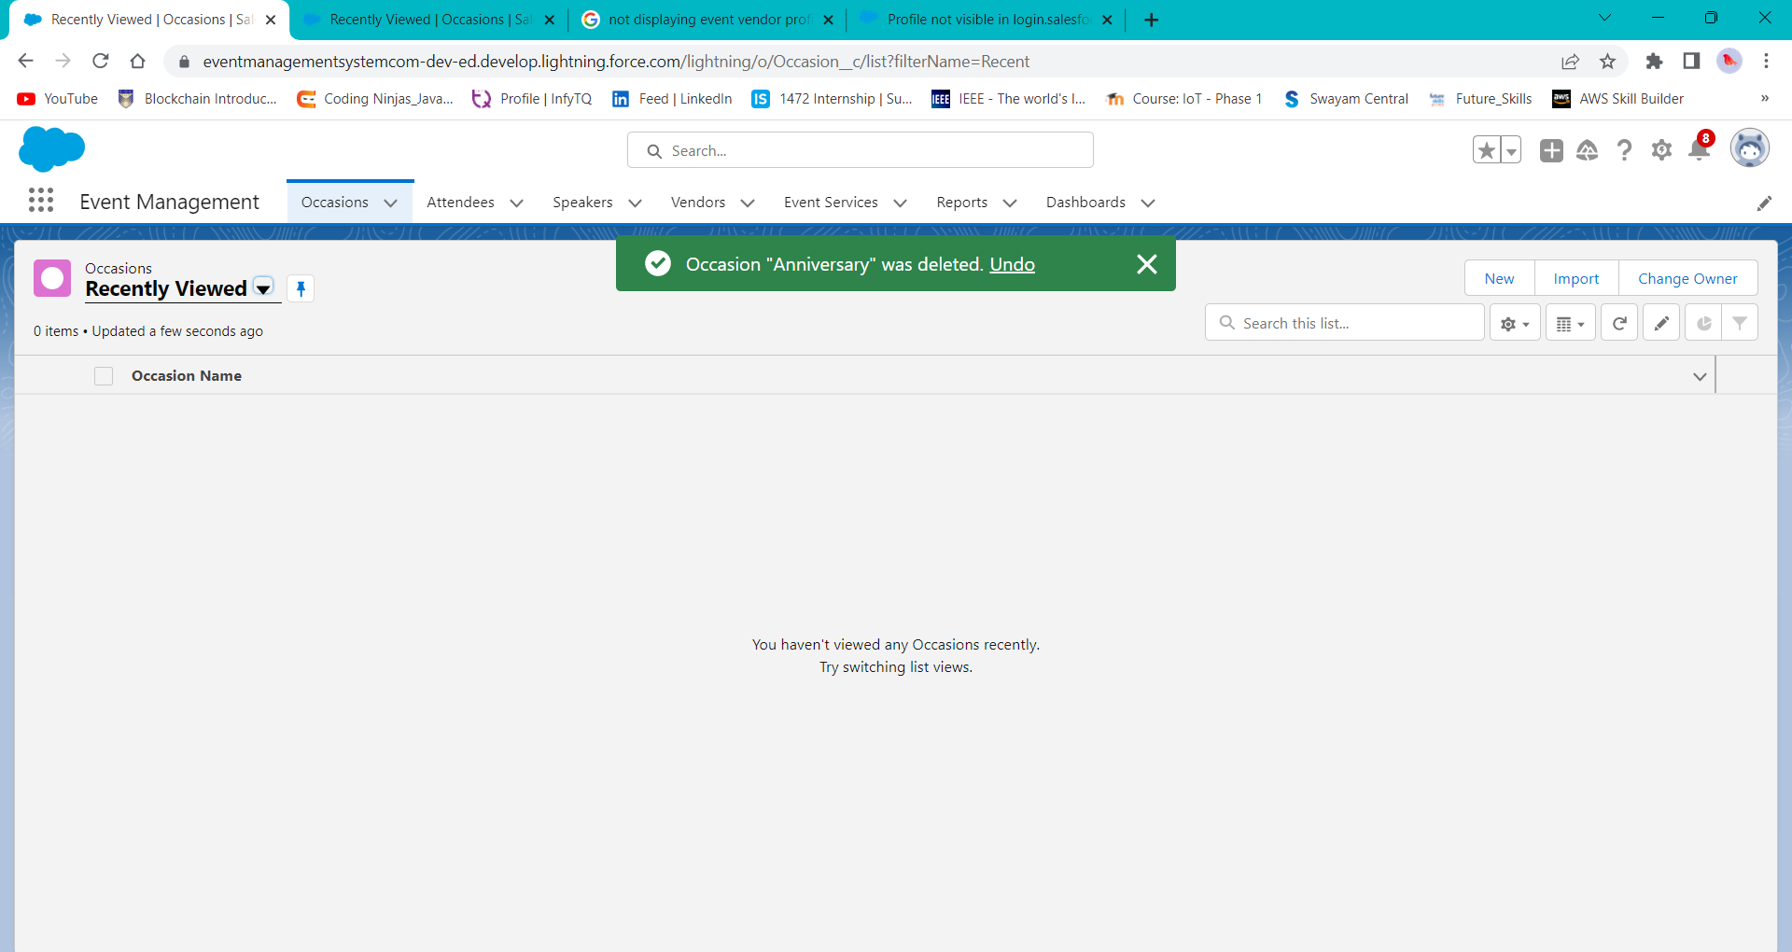

* + Reports
    - Creating A Report

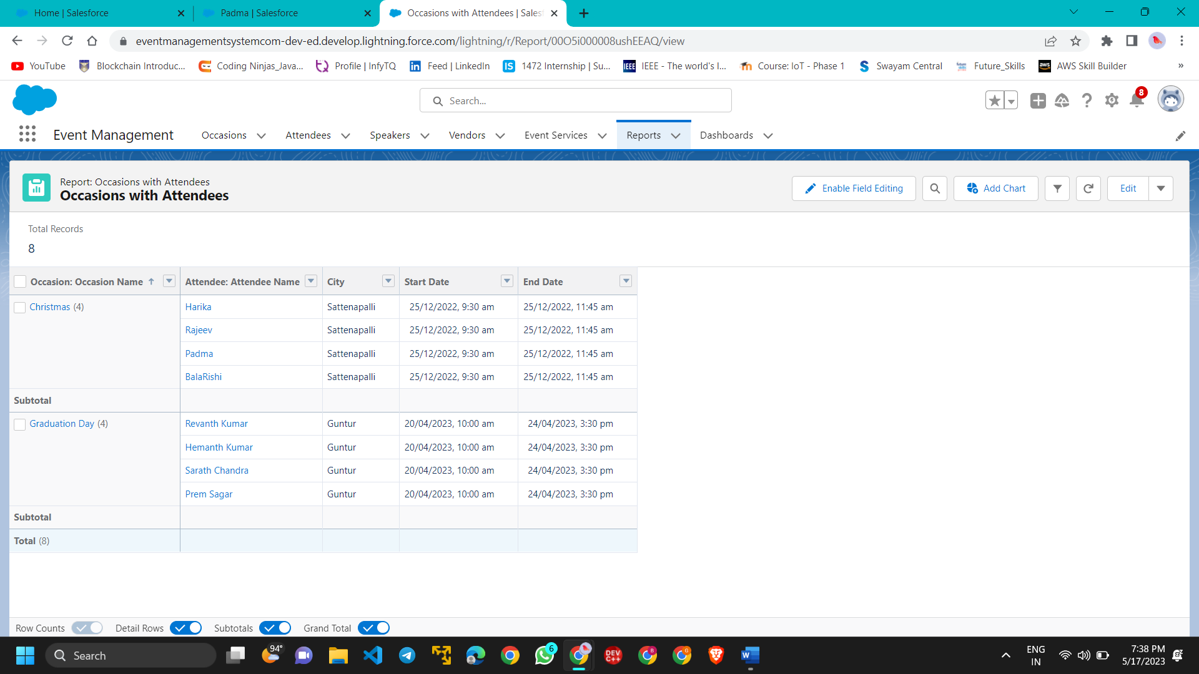

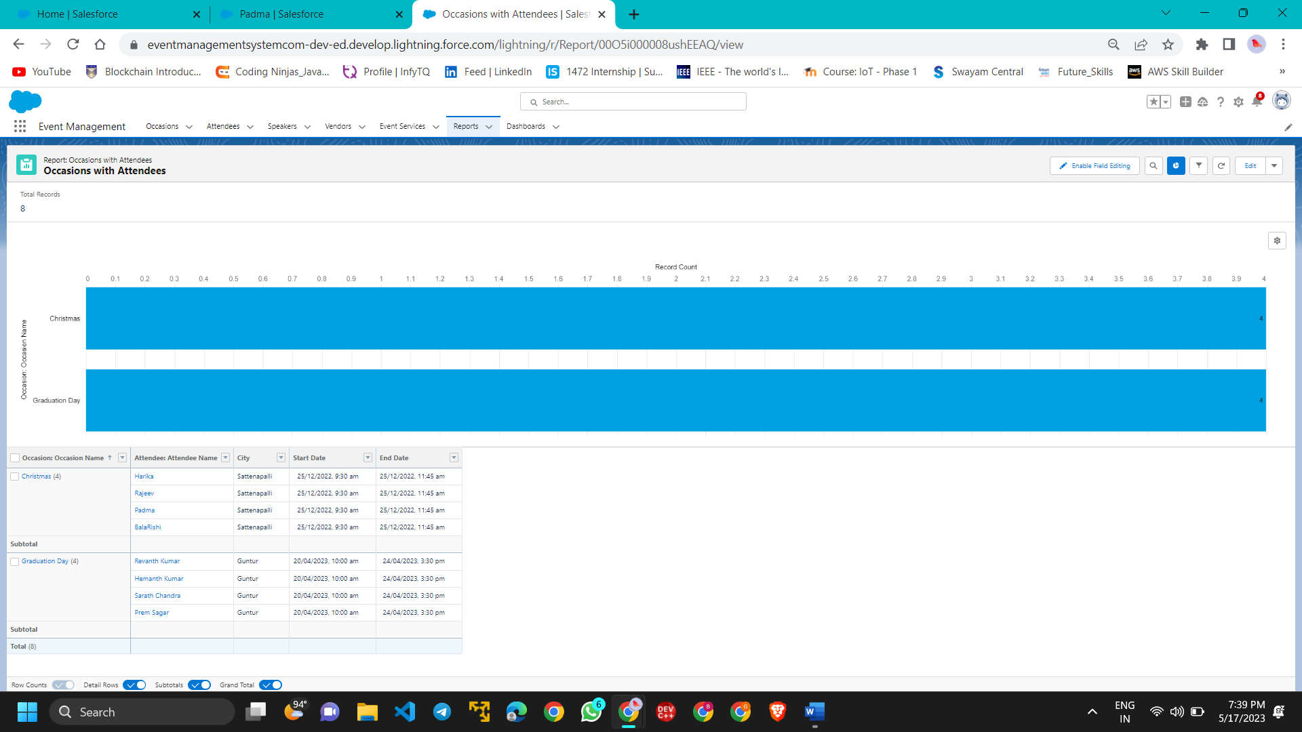

* + Dashboard
    - Create A Dashboard

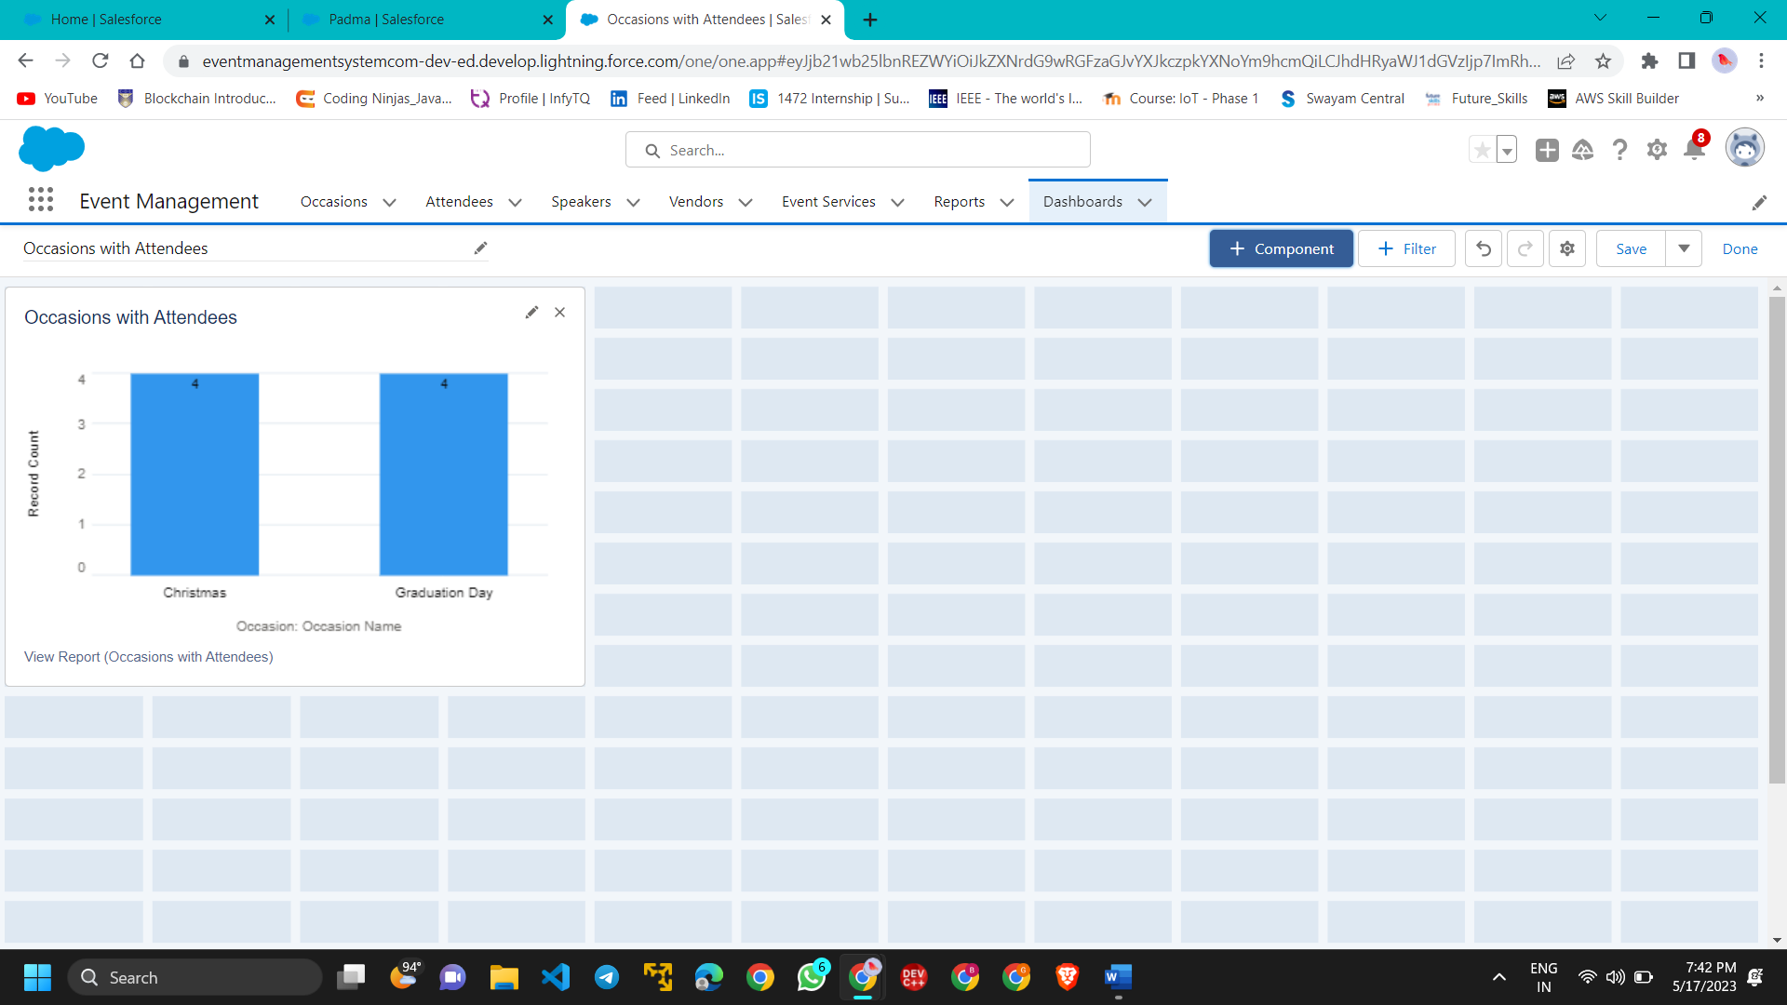

* + View Reports And Dashboards
    - View Report

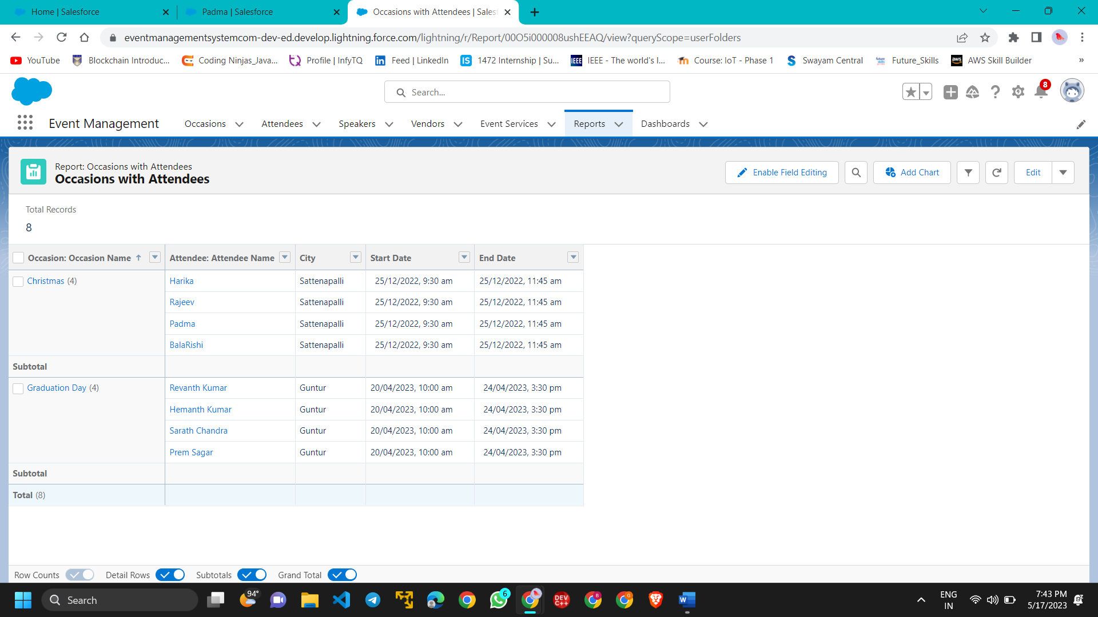

* + - View Dashboard

